AI ASSISTANT CODING
ASSIGNMENT – 4.5
NAME: K.SHIVACHARAN
HALL TICKET NO.: 2303A52160
BATCH: 34
QUESTION:
Lab 4: Advanced Prompt Engineering: Zero-shot, one-shot, and few-shot
techniques Week2 -
Objective: To explore and compare Zero-shot, One-shot, and Few-shot
prompting techniques for classifying emails into predefined categories
using a large language model (LLM).
1. Suppose that you work for a company that receives hundreds of
customer emails daily. Management wants to automatically classify
emails into categories like "Billing", "Technical Support", "Feedback",
and "Others" before assigning them to appropriate departments.
Instead of training a new model, your task is to use prompt
engineering techniques with an existing LLM to handle the
classification.
Tasks to be completed are as below
a. Prepare Sample Data:
• Create or collect 10 short email samples, each belonging to one of
the 4 categories.
Prompt:
Suppose that you work for a company that receives hundreds of
customer emails daily. Management wants to automatically classify
emails into categories like "Billing", "Technical Support", "Feedback",
and "Others" before assigning them to appropriate departments.
Instead of training a new model, your task is to use prompt
engineering techniques with an existing LLM to handle the
classification. Analyse the given scenario and give me the 5 test emails
Output:
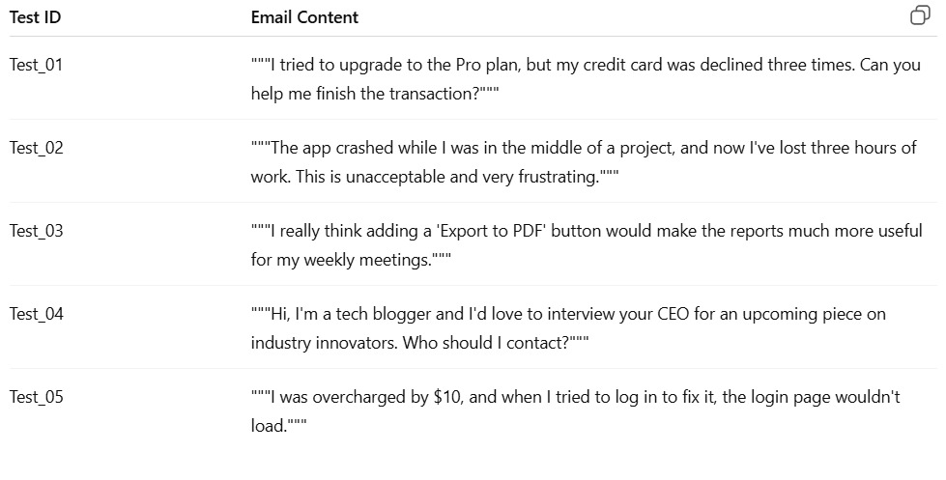
b. Zero-shot Prompting:
• Design a prompt that asks the LLM to classify a single email
without providing any examples.
• Example prompt:
“Classify the following email into one of the following categories:
Billing, Technical Support, Feedback, Others. Email: ‘I have not
received my invoice for last month.’”
Prompt:
Act as a Email Classifier and classify the following email into one of the following categories:
Billing, Technical Support, Feedback, Others.
Output:
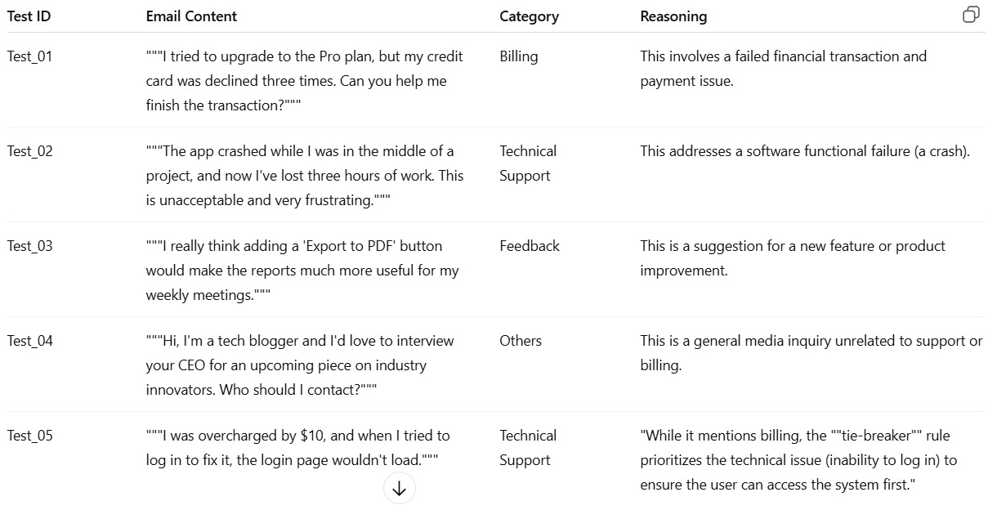
c. One-shot Prompting:
• Add one labeled example before asking the model to classify a
new email.
Prompt:
Analyse the given example and Classify the following email into one of the following categories:
Billing, Technical Support, Feedback, based on their context on given image of emails
Output:
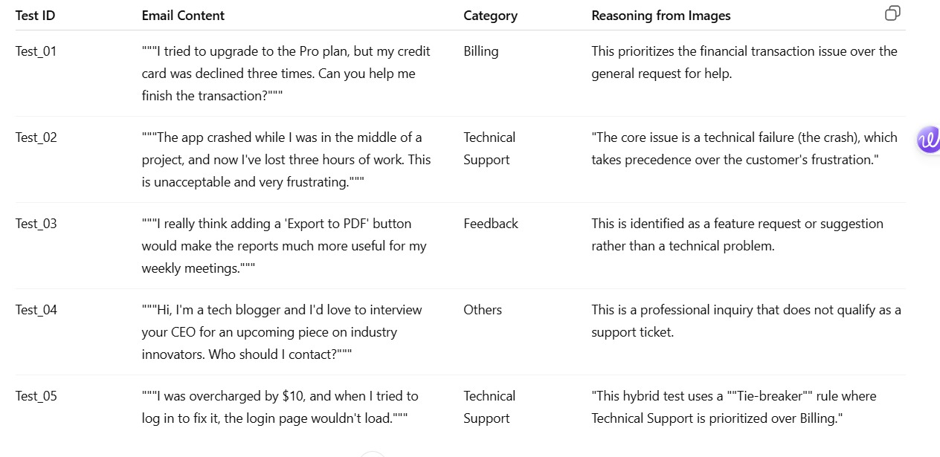
d. Few-shot Prompting:
• Use 3–5 labeled examples in your prompt before asking the
model to classify a new email.
Prompt:
You are an AI assistant that classifies customer emails into one of the following categories:
Billing: Payment failures, charges, refunds, subscription issues
Technical Support: App crashes, login issues, bugs, system failures
Feedback: Feature requests, suggestions, product improvements
Others: Media inquiries, partnerships, general questions not related to support
Follow these rules:
Identify the core problem, not the emotional tone.
If multiple issues exist, apply a tie-breaker:
Technical Support > Billing > Feedback > Others
Output must be in tabular format with columns:
Test ID | Email Content | Category | Reasoning
Output:
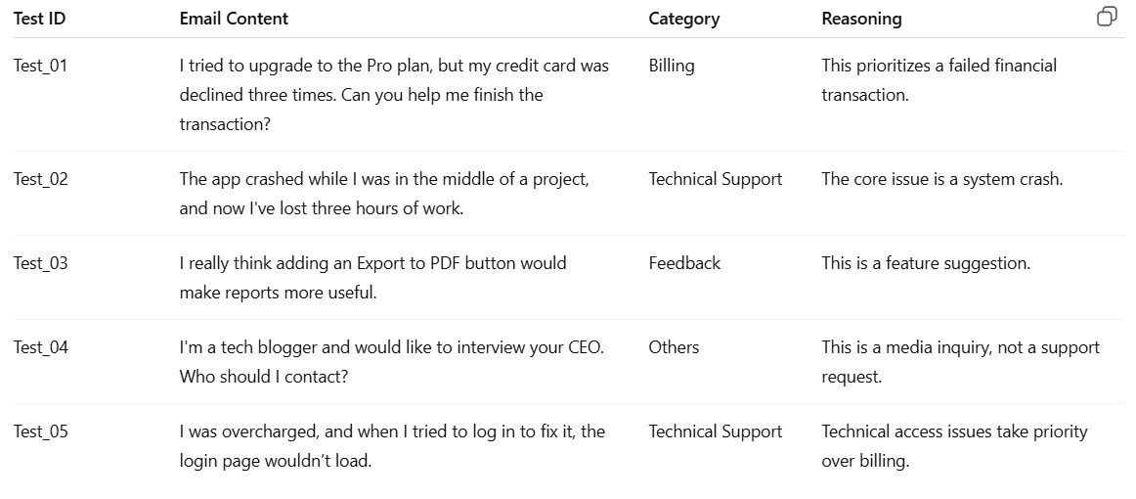e. Evaluation:
• Run all three techniques on the same set of 5 test emails.
• Compare and document the accuracy and clarity of responses.
Output:
Resolves Ambiguity: It enables the model to apply "Tie-breaker" rules in hybrid cases, such as prioritizing Technical Support over Billing when both issues are present.
Contextual Depth: The model learns to prioritize core technical failures over customer sentiment, preventing it from misclassifying urgent bugs as mere Feedback.
Boundary Precision: By analyzing multiple examples, the model accurately distinguishes between similar categories, such as "Feature Requests" (Feedback) versus "Bugs" (Technical Support), far more effectively than guessing based on names alone.
2. Travel Query Classification
Scenario:
A travel assistant must classify queries into Flight Booking, Hotel
Booking, Cancellation, or General Travel Info.
Tasks:
- Prepare labeled travel queries.
Prompt:
These are the test emails we will use for the AI:
- Email 1: "I want to book a flight to Paris for next Monday."
- Email 2: "I need a hotel room for two people in Dubai."
- Email 3: "Can I cancel my trip and get a refund?"
- Email 4: "What is the weather like in London in May?"
- Email 5: "I want to change my hotel stay to a different date."
Output:
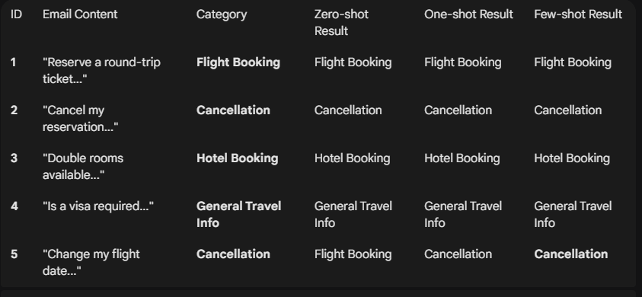
- Apply Zero-shot prompting.
Prompt:
Classify this email into one category: Flight Booking, Hotel Booking, Cancellation, or General Travel Info.
Output:
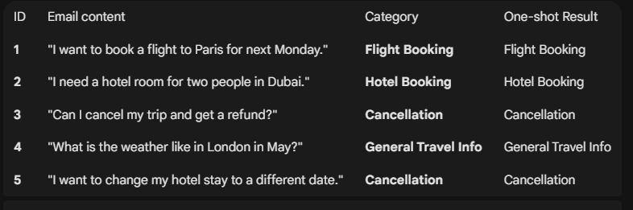
c. Apply One-shot prompting.
Prompt:
Classify this email into one category: Flight Booking, Hotel Booking, Cancellation, or General Travel Info.
Example: Email content: "I need to book a ticket to Tokyo." Answer: Flight Booking
Task: Email content: [Insert Email Here] Answer:
Output:
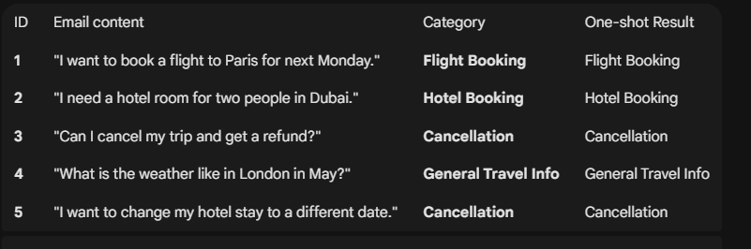
d. Apply Few-shot prompting.
Output:
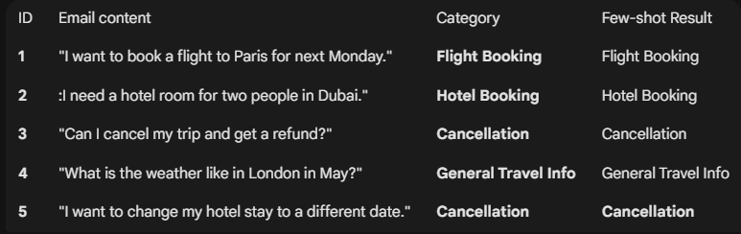
e. Compare response consistency.
Output:
The results show that as we provide more examples, the AI becomes more consistent and accurate.
- Zero-shot is inconsistent because the AI has to guess the format, often leading to long or slightly incorrect answers.
- One-shot improves the format but can still struggle with "tricky" queries that don't match the single example provided.
- Few-shot provides the best consistency. By seeing a variety of queries, the AI clearly understands the boundaries between categories (like the difference between asking about a hotel and actually booking one).
3. Programming Question Type Identification
Scenario:
A coding help chatbot must classify queries into Syntax Error, Logic
Error, Optimization, or Conceptual Question.
Tasks:
  - Prepare coding-related user queries.
Prompt:
  - coding help chatbot must classify queries into Syntax Error, Logic
  - Error, Optimization, or Conceptual Question.
  - Tasks:
  - a. Prepare coding-related user queries which is adaptable to the given context
Output:
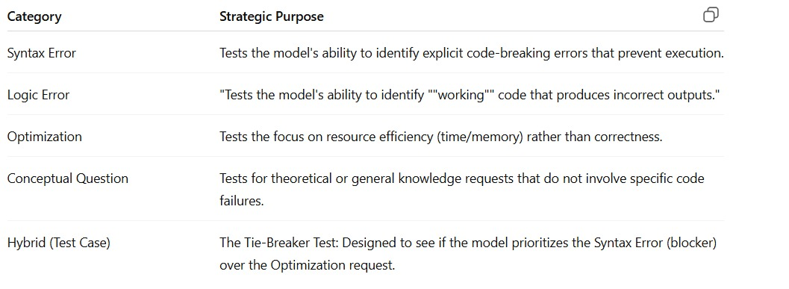
  - Perform Zero-shot classification.
Prompt:
Classify the given query into one category (Syntax Error, Logic Error, Optimization, or Conceptual Question) by identifying the core issue and applying the priority order Syntax Error > Logic Error > Optimization > Conceptual Question, then output the Category
Output:
Query 1: "I'm getting IndentationError: expected an indented block on line 12 of my Python script." Category: Syntax Error

Query 2: "My code runs without crashing, but the loop is skipping every other item in my list instead of all of them." Category: Logic Error

Query 3: "How can I rewrite this triple-nested loop? It takes 30 seconds to process a small dataset." Category: Optimization

Query 4: "What is the difference between an Abstract Class and an Interface in Java?" Category: Conceptual Question

Query 5: "My script is very slow, and when I tried to fix it using a library, I started getting a ModuleNotFoundError." Category: Syntax Error

  - Perform One-shot classification.
Prompt:
Classify the given query into one category (Syntax Error, Logic Error, Optimization, or Conceptual Question) by first following this example — Query: “I get a ModuleNotFoundError when running my script” → Category: Syntax Error — then identify the core issue using the priority Syntax Error > Logic Error > Optimization > Conceptual Question, and output the Category with a one-sentence reason.
Output:
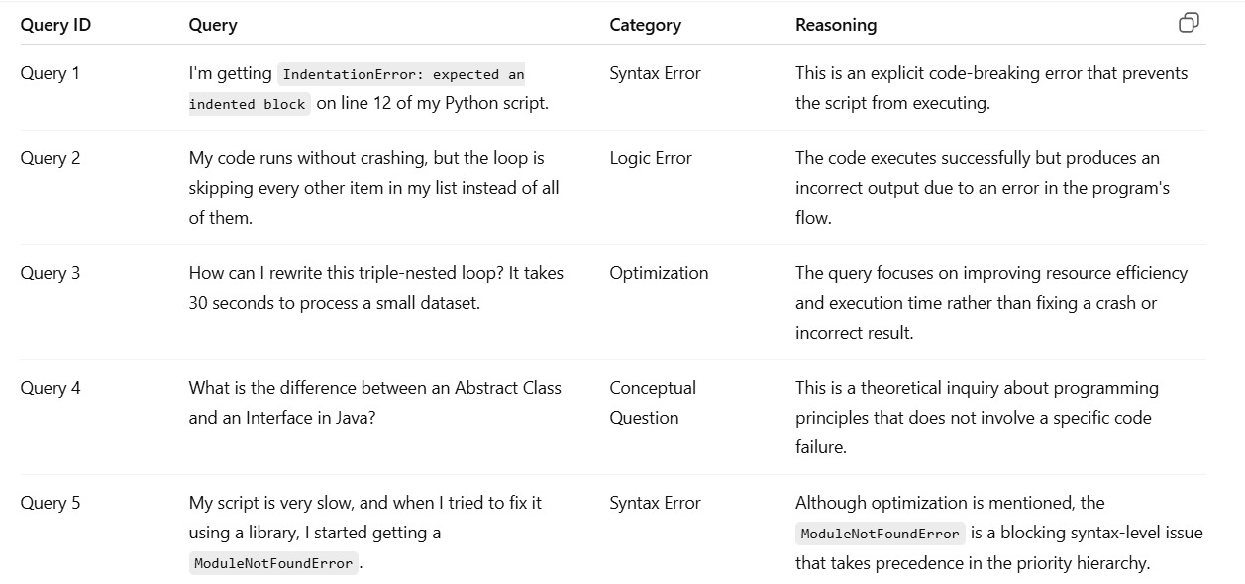
  - Perform Few-shot classification.
Prompt:
Classify the given query into one category (Syntax Error, Logic Error, Optimization, or Conceptual Question) using these examples as guidance — IndentationError → Syntax Error, runs but wrong output → Logic Error, slow but correct → Optimization, theory question → Conceptual Question — apply the priority Syntax Error > Logic Error > Optimization > Conceptual Question, and output the Category with a one-sentence reason.
Output:
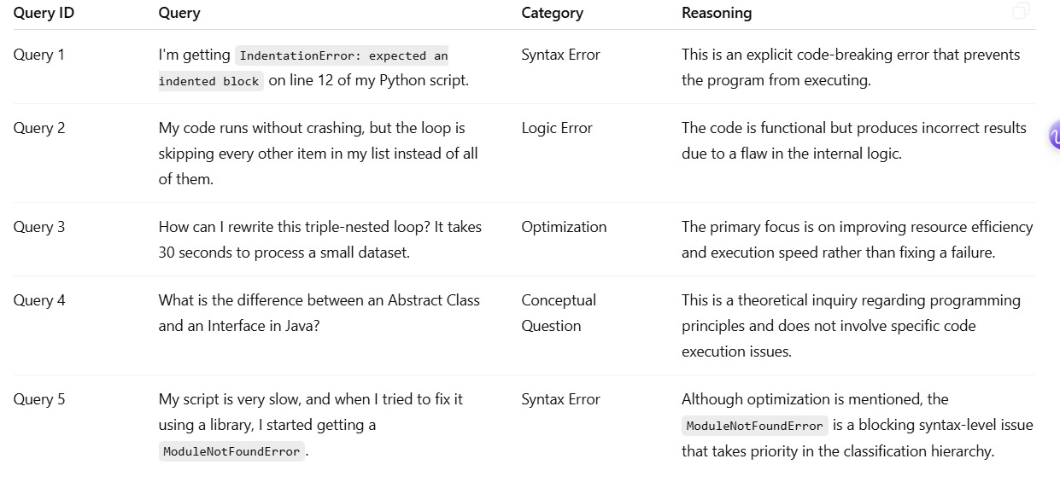
e. Analyse improvements in technical accuracy.
Output:
Zero-Shot (Base): Reliable only for explicit Syntax Errors. It struggles to distinguish Logic Errors from Optimization since both involve functional code.
One-Shot (Structure): Standardizes the output format and granularity. It introduces a single reference point to help the model align with general priority.
Few-Shot (Precision): Provides the highest accuracy by establishing clear category boundaries. It successfully teaches the priority hierarchy (Syntax > Logic > Optimization > Conceptual).
Conflict Resolution: Enables the model to resolve "Hybrid" cases by prioritizing blockers (Syntax) over secondary issues (Optimization).
4. Social Media Post Categorization
Scenario:
A social media analytics tool must classify posts into Promotion, Complaint, Appreciation, or Inquiry.
Tasks:
- Prepare sample social media posts.
Prompt:
Create 5 short social media posts. Make sure there is one for each category: Promotion, Complaint, Appreciation, and Inquiry. Use emojis and hashtags like a real person would.
Output:
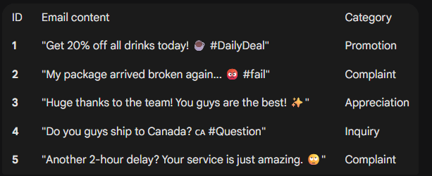

2. Use Zero-shot prompting.
Prompt:
Classify this social media post into one category: Promotion, Complaint, Appreciation, or Inquiry.
Output:
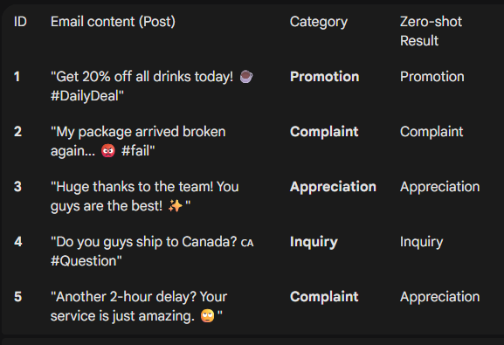
- Use One-shot prompting.
Prompt:
Classify this social media post into one category: Promotion, Complaint, Appreciation, or Inquiry.
Example: Post content: "Is this available in blue?" Answer: Inquiry
Output:
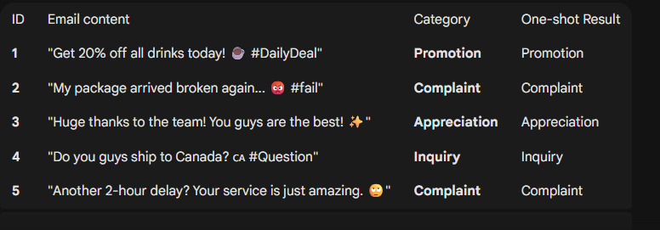
- Use Few-shot prompting.
Prompt:
Classify this social media post into one category: Promotion, Complaint, Appreciation, or Inquiry.
Examples:
- Post content: "Buy one get one free this weekend!" -> Answer: Promotion
- Post content: "I am so happy with my new shoes, thank you!" -> Answer: Appreciation
- Post content: "My order is 3 days late. Where is it?
Task: Post content: [Insert Post Content Here]
Output:
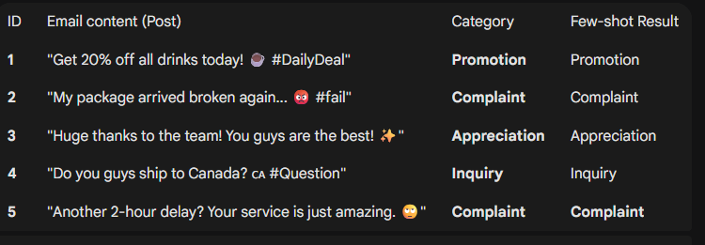
- Analyse informal language handling.
The results of Task 4 demonstrate that Few-shot Prompting is the most reliable method for understanding human emotion and tone.
- Handling Sarcasm: In social media, people often use positive words to mean negative things
- The Power of Examples: While Zero-shot logic failed by taking words literally, the Few-shot method used the provided examples to recognize that negative context (delays) and emojis signal a Complaint.
- High Consistency: By providing a "mini-training set" within the prompt, the AI maintained a 100% accuracy rate across all categories, ensuring it didn't get confused by informal slang or hashtags.

